# 3. INTERFACE DESIGN

## 3.1. Introduction

This document describes the User Interface for the KarryWell client-web and mobile app.

This document is divided into the following sections:

* Structure and layout describes the structure of the application, screen flow
* Screen Descriptions, which comprises the main part of the document, contains a detailed description of each screen and its component parts.

## 3.2. Interface Design of Application

### 3.2.1. Structure and Layout

The overall structure of the application is relatively simple, as shown in the following diagram.

|  |  |  |
| --- | --- | --- |
| **No** | **Screen Name** | **Description** |
|  | Dashboard Screen | Displays overview of system about Shipper, Store, Order, Task and Finance |
|  | Create Order Screen | Where admin can create new order |
|  | Order’s List Screen | Displays all orders and related information |
|  | Add Store Screen | Where admin can add new store to system. |
|  | Store’s List Screen | Displays all stores and related information |
|  | Transaction History Screen | Displays all transactions and related information |
|  | Add New Shipper Screen | Where admin can add new shipper to system. |
|  | Shipper’s List Screen | Displays all shippers and related information |
|  | Task’s List Screen | Displays all tasks and related information |
|  | Assign Task Screen | Where admin can assign order to shipper |
|  | IssueBox Screen | Displays all issues and related information |
|  | Report Screen | Displays statistics of system about Shipper, Store, Order, Task and Finance |
|  | User Detail Screen | Displays user’s detail, so admin can update these information |
|  | Store Detail Screen | Displays store’s detail, so admin can update these information |

**Screen flow :**

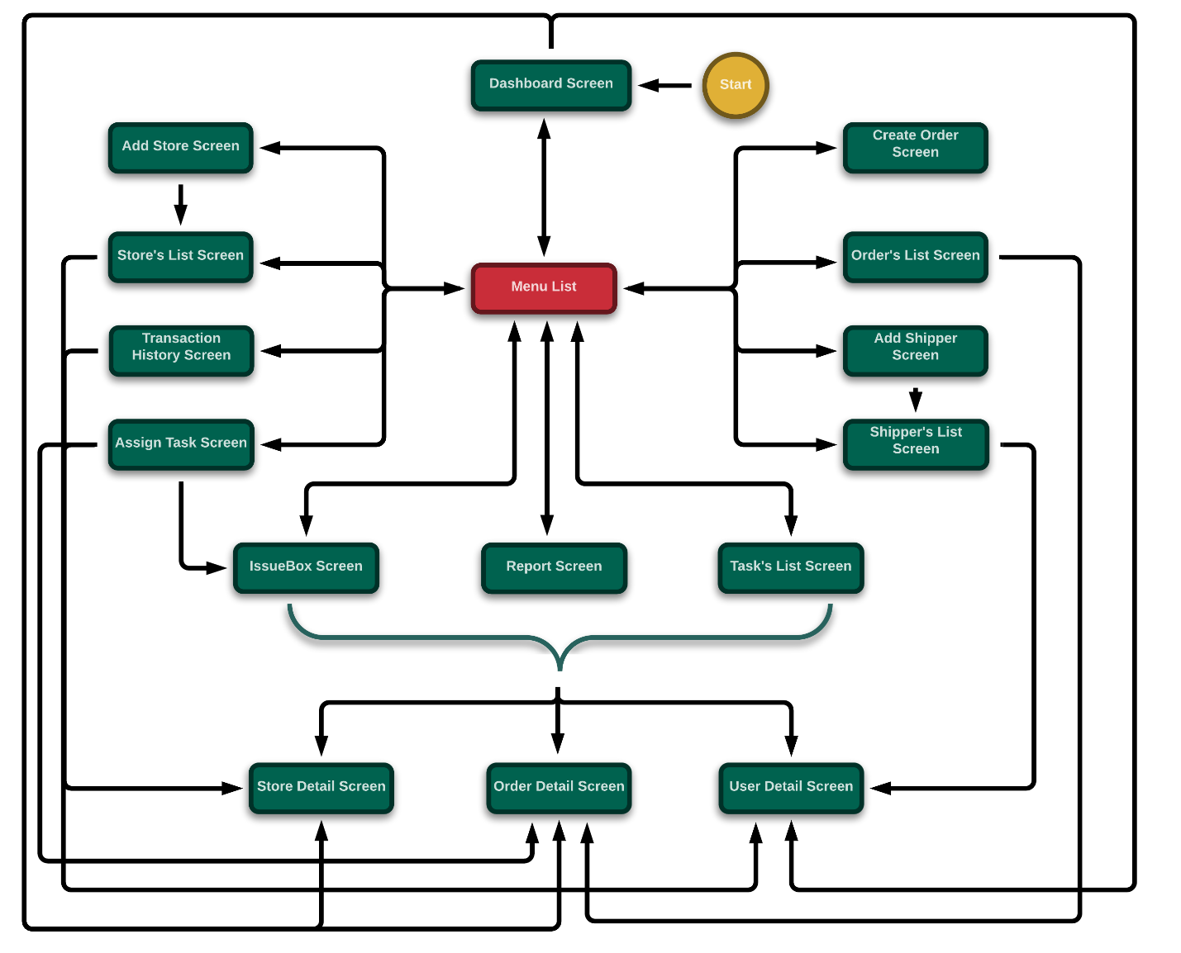

*Figure 124: Screen flow of KarryWell client-web for Admin*

### 3.2.2. Screen Description

#### 3.2.2.1. Dashboard Screen

This is the first screen after Admin logged in system where overview of system is displayed

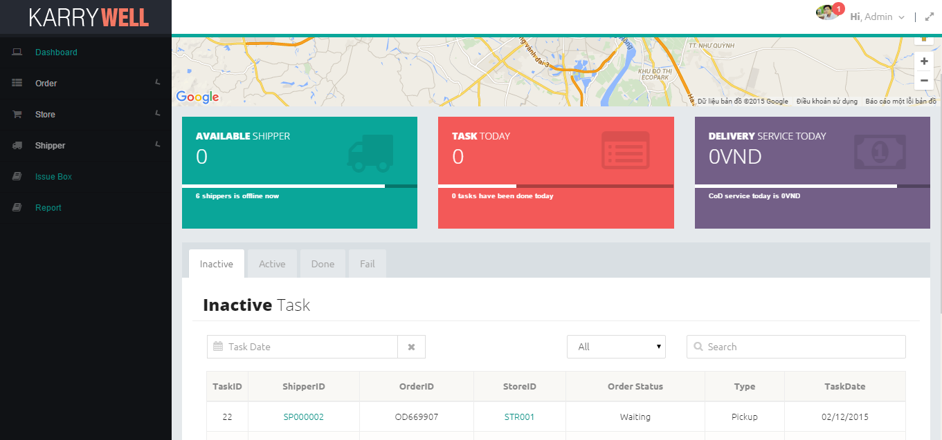

|  |  |  |  |  |  |
| --- | --- | --- | --- | --- | --- |
| **No** | **Elements** | **Sub-Element** | **Required** | **Type** | **Description** |
|  | **Menu** |  | Click | List view | List of the pages ( Dashboard , Order(*Create Order ,Order’s List*) , Store(*Add Store, Store’s List, Transaction History*), Shipper*(Add Shipper, Shipper’s List, Task’s List, Assign Task*), Report , IssueBox ) which navigate directly to selected page |
|  | **KARRYWELL logo** |  |  | Image | Logo of system |
|  | **Header** | Avatar |  | Image | Avatar of user |
| Notification | Click | Button | Number of unread notification, click to view notification list |
| Greeting | Click | Drop-downlist | Include ‘Sign out’, ‘View Profile’ to log out or view user’s profile |
| Full size | Click | Button | Click to view page on full-screen |
|  | **Map** |  |  | Google map item | Map of all stores and online shippers |
|  | **Shipper box** |  |  | Box item | Displays number of online and offline shipper |
|  | **Task box** |  |  | Box item | Displays number of tasks today and tasks which have been done today |
|  | **Finance box** |  |  | Box item | Displays total delivery cost and cash on delivery |
|  | **Task tab** |  | Click | Tab item | There are 4 tabs: Inactive, Active, Done, Fail. Each tab includes a table of tasks have specific status |
|  | **Task table** | **Date range** | Click | Daterange-picker | Select date range for searching |
| **Clear** | Click | Button | Clear date range value |
| **Type filter** | Click | Drop-downlist | Select type for searching |
| **Search** |  | Textbox | Enter search key for searching |
| **Table** |  | Table item | Displays tasks and related information (taskid, shipperid, orderid, storeid, order status, type, task date) |
| **Page navigation** | Click | Navigation item | Click to select page number |

#### 3.2.2.2. Add Store Screen

When admin wants to add a new Store, admin have to create an account for store’s owner and store profile

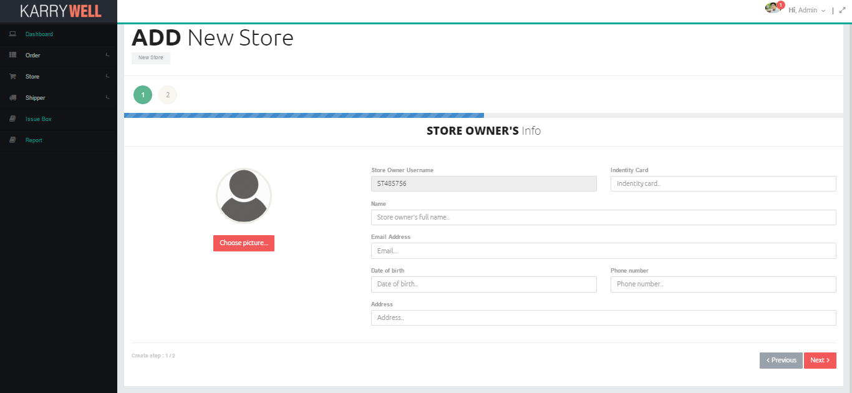

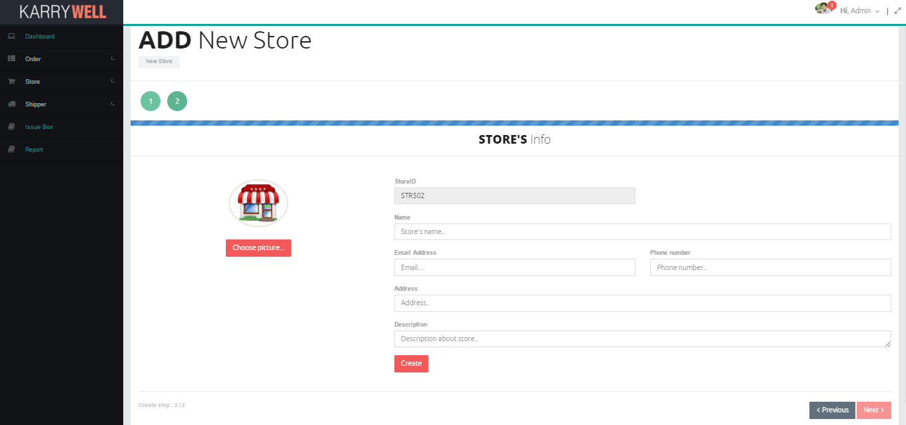

|  |  |  |  |  |  |
| --- | --- | --- | --- | --- | --- |
| **No** | **Elements** | **Sub-Element** | **Required** | **Type** | **Description** |
| 1. **1** | **Menu** |  | Click | List view | List of the pages ( Dashboard , Order(*Create Order ,Order’s List*) , Store(*Add Store, Store’s List, Transaction History*), Shipper*(Add Shipper, Shipper’s List, Task’s List, Assign Task*), Report , IssueBox ) which navigate directly to selected page |
| 1. **2** | **KARRYWELL logo** |  |  | Image | Logo of system |
| 1. **3** | **Header** | Avatar |  | Image | Avatar of user |
| Notification | Click | Button | Number of unread notification, click to view notification list |
| Greeting | Click | Drop-downlist | Include ‘Sign out’, ‘View Profile’ to log out or view user’s profile |
| Full size | Click | Button | Click to view page on full-screen |
| 1. **4** | **Add New Store title** |  |  | Label | Title |
| 1. **5** | **Step button** |  |  | Button | Step of adding store process |
| 1. **6** | **Form of step1** | **Store Owner Info Title** |  | Label | Title of form |
| **Avatar** |  | Image | Avatar of new shipper |
| **Store Owner Username** |  | Textbox | Store’s Owner username of new store |
| **Identity card** |  | Textbox | Identity card of new store’s owner |
| **Name** |  | Textbox | Full name of new store’s owner |
| **Email** |  | Textbox | Email of new store’s owner |
| **Date of Birth** | Click | DatePicker item | Date of birth of new store’s owner |
| **Phone number** |  | Textbox | Phone number of new store’s owner |
| **Address** |  | Textbox | Address of new store’s owner |
| **Next** | Click | Button | Click to go to next step |
| **Previous** | Click | Button | Click to go to previous step |
| **Choose picture** | Click | Button | Click to add choose avatar for new Shipper |
| 1. **7** | **Form of step2** | **Store Owner Info Title** |  | Label | Title of form |
| **Avatar** |  | Image | Avatar of new store |
| **StoreID** |  | Label | StoreID of new store |
| **Name** |  | Textbox | Name of new store |
| **Email** |  | Textbox | Email of new store |
| **Phone number** |  | Textbox | Phone number of new store |
| **Address** |  | Textbox | Address of new store |
| **Description** |  | Textbox | Description about new store |
| **Choose picture** | Click | Button | Click to add choose avatar for new Shipper |
| **Create** | Click | Button | Click to create new store with entered information |
| **Next** | Click | Button | Click to go to next step |
| **Previous** | Click | Button | Click to go to previous step |

#### 3.2.2.3. Store’s List Screen

Admin can view all store of system in map and in table

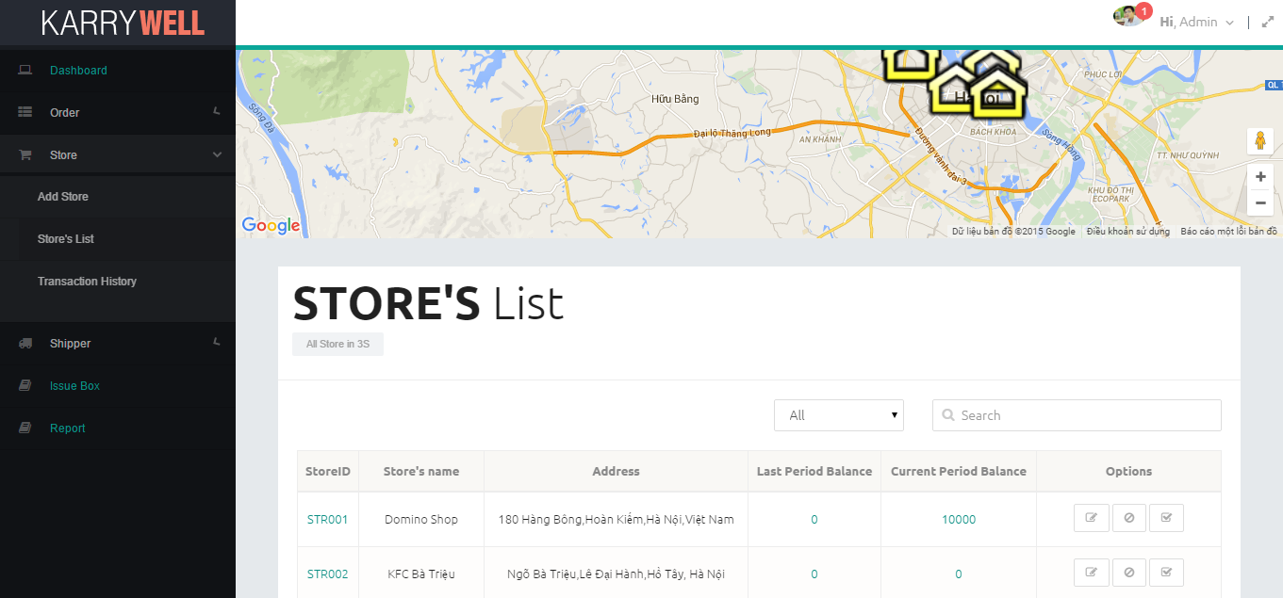

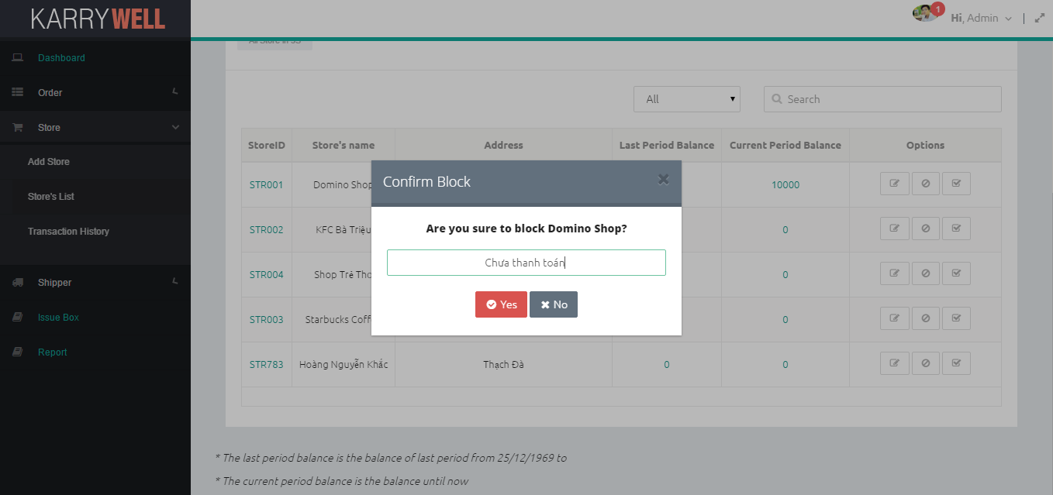

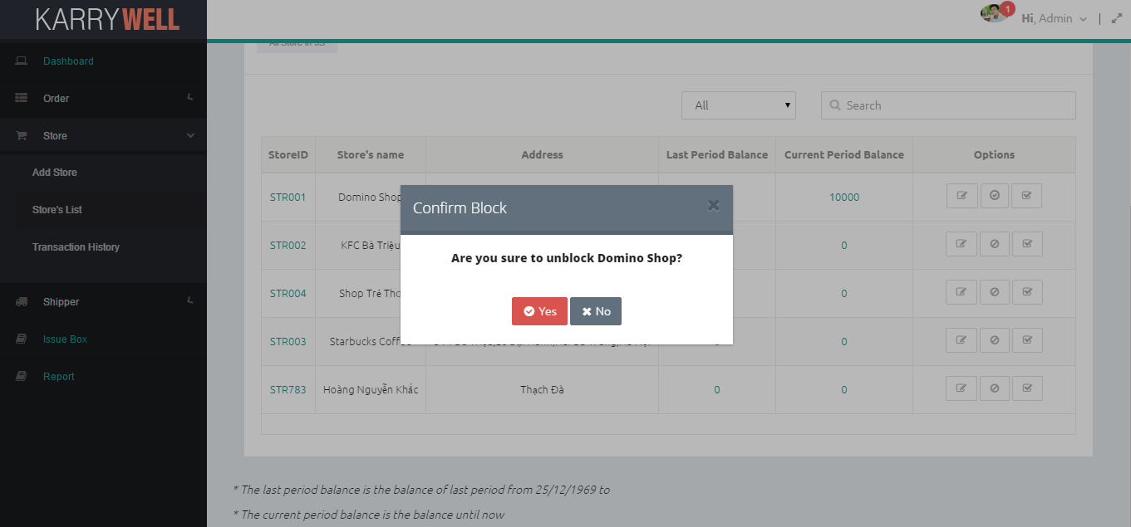

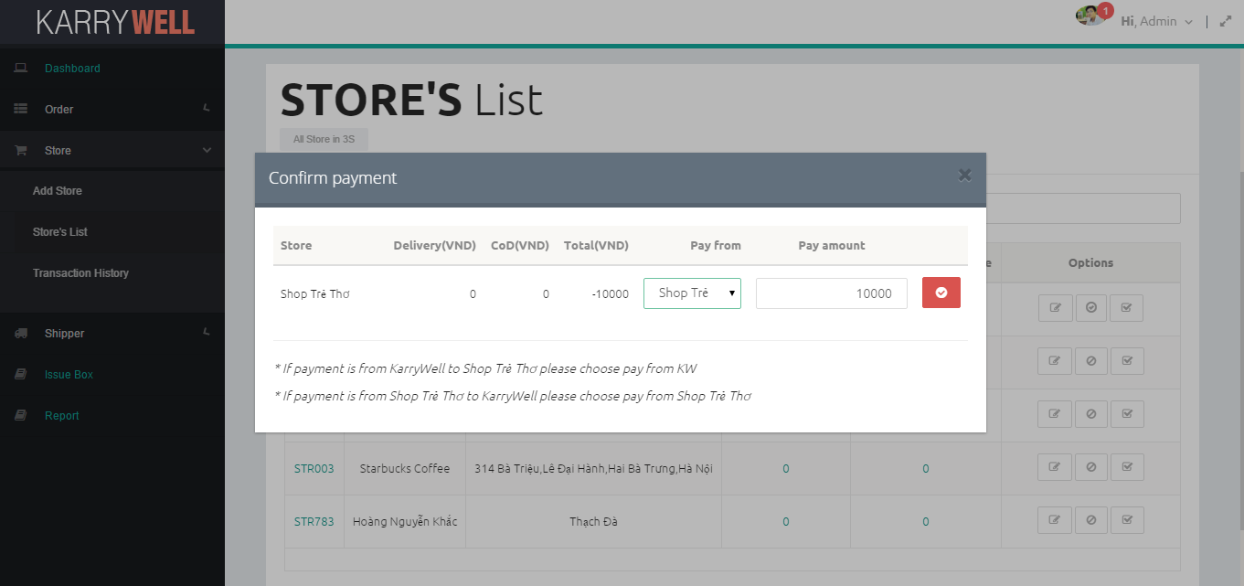

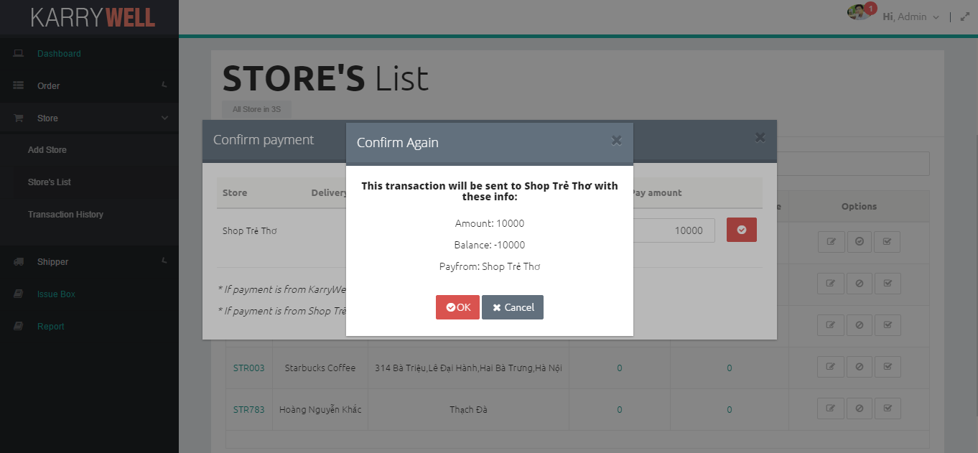

|  |  |  |  |  |  |  |
| --- | --- | --- | --- | --- | --- | --- |
| **No** | **Elements** | **Sub-Element** | **Required** | **Type** | **Default** | **Description** |
|  | **Menu** |  | Click | List view |  | List of the pages ( Dashboard , Order(*Create Order ,Order’s List*) , Store(*Add Store, Store’s List, Transaction History*), Shipper*(Add Shipper, Shipper’s List, Task’s List, Assign Task*), Report , IssueBox ) which navigate directly to selected page |
|  | **KARRYWELL logo** |  |  | Image |  | Logo of system |
|  | **Header** | Avatar |  | Image |  | Avatar of user |
| Notification | Click | Button |  | Number of unread notification, click to view notification list |
| Greeting | Click | Drop-downlist |  | Include ‘Sign out’, ‘View Profile’ to log out or view user’s profile |
| Full size | Click | Button |  | Click to view page on full-screen |
|  | **Store’s List title** |  |  | Label |  | Title |
|  | **Store table** | **Date range** | Click | Daterange-picker |  | Select date range for searching |
| **Clear** | Click | Button |  | Clear date range value |
| **Type filter** | Click | Drop-downlist |  | Select type for searching |
| **Search** |  | Textbox |  | Enter search key for searching |
| **Table** |  | Table item |  | Displays all stores and related information (storeid, name, address, last balance period, current balance, update, block and confirm payment button) |
| **Page navigation** | Click | Navigation item |  | Click to select page number |
|  | **Notes** |  |  | Label |  | Bonus information about time of last balance period and current balance period |
|  | **Block Store Popup** | **Popup title** |  | Label | Hide | “Confirm Block” title |
| **Close** | Click | Button | Hide | Click to close popup |
| **Confirm** |  | Label | Hide | Confirmation text |
| **Reason** |  | Textbox | Hide | Enter why store is blocked |
| **Yes** | Click | Button | Hide | Click to confirm yes |
| **No** | Click | Button | Hide | Click to cancel |
|  | **Unblock Store Popup** | **Popup title** |  | Label | Hide | “Confirm Unblock” title |
| **Close** | Click | Button | Hide | Click to close popup |
| **Confirm** |  | Label | Hide | Confirmation text |
| **Yes** | Click | Button | Hide | Click to confirm yes |
| **No** | Click | Button | Hide | Click to cancel |
|  | **Confirm Payment Popup** | **Popup title** |  | Label | Hide | “Confirm Payment” title |
| **Close** | Click | Button | Hide | Click to close popup |
| **Payment table** | Click | Table item | Hide | Contains a row: store’s name, deliver, cod, total, pay from drop-downlist, amount textbox, confirm button |
| **Notes** |  | Label | Hide | Note about this process |
|  | **Confirm Again Popup** | **Popup title** |  | Label | Hide | “Confirm Again” title |
| **Close** | Click | Button | Hide | Click to close popup |
| **Confirm** |  | Label | Hide | Confirmation text |
| **Yes** | Click | Button | Hide | Click to confirm yes |
| **Cancel** | Click | Button | Hide | Click to cancel |

#### 3.2.2.4. Transaction History Screen

All transactions and related information is displayed in table

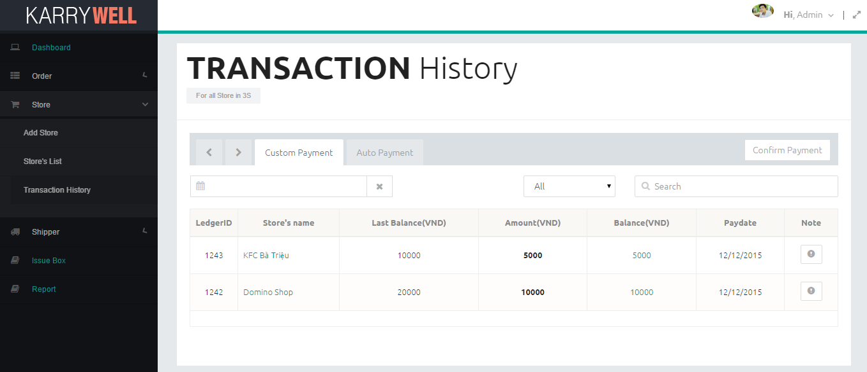

|  |  |  |  |  |  |
| --- | --- | --- | --- | --- | --- |
| **No** | **Elements** | **Sub-Element** | **Required** | **Type** | **Description** |
| 1. **1** | **Menu** |  | Click | List view | List of the pages ( Dashboard , Order(*Create Order ,Order’s List*) , Store(*Add Store, Store’s List, Transaction History*), Shipper*(Add Shipper, Shipper’s List, Task’s List, Assign Task*), Report , IssueBox ) which navigate directly to selected page |
| 1. **2** | **KARRYWELL logo** |  |  | Image | Logo of system |
| 1. **3** | **Header** | Avatar |  | Image | Avatar of user |
| Notification | Click | Button | Number of unread notification, click to view notification list |
| Greeting | Click | Drop-downlist | Include ‘Sign out’, ‘View Profile’ to log out or view user’s profile |
| Full size | Click | Button | Click to view page on full-screen |
| 1. **4** | **Transaction History title** |  |  | Label | Title |
| 1. **5** | **Next tab** |  | Click | Button | Move to next tab when clicking |
| 1. **6** | **Previous tab** |  | Click | Button | Move to previous tab when clicking |
| 1. **7** | **Confirm Payment** |  | Click | Button | Redirect to Store’s List page |
| 1. **8** | **Transaction tab** |  | Click | Tab item | There are 2 tabs: Custom Payment, Auto Payment tab includes a table of transaction of custom payment and auto payment |
|  | **Custom Payment table** | **Date range** | Click | Daterange-picker | Select date range for searching |
| **Clear** | Click | Button | Clear date range value |
| **Type filter** | Click | Drop-downlist | Select type for searching |
| **Search** |  | Textbox | Enter search key for searching |
| **Table** |  | Table item | Displays transaction is added by admin and related information (ledgerid, store’s name, last balance, amount, balance, pay date) |
| **Page navigation** | Click | Navigation item | Click to select page number |
|  | **Auto Payment table** | **Date range** | Click | Daterange-picker | Select date range for searching |
| **Clear** | Click | Button | Clear date range value |
| **Type filter** | Click | Drop-downlist | Select type for searching |
| **Search** |  | Textbox | Enter search key for searching |
| **Table** |  | Table item | Displays transaction is added automatically by system and related information (ledgerid, store’s name, total, delivery, cod, period date). |
| **Page navigation** | Click | Navigation item | Click to select page number |

#### 3.2.2.5. Add Shipper Screen

When admin wants to add a new Shipper, admin have to enter information of shipper’s profile

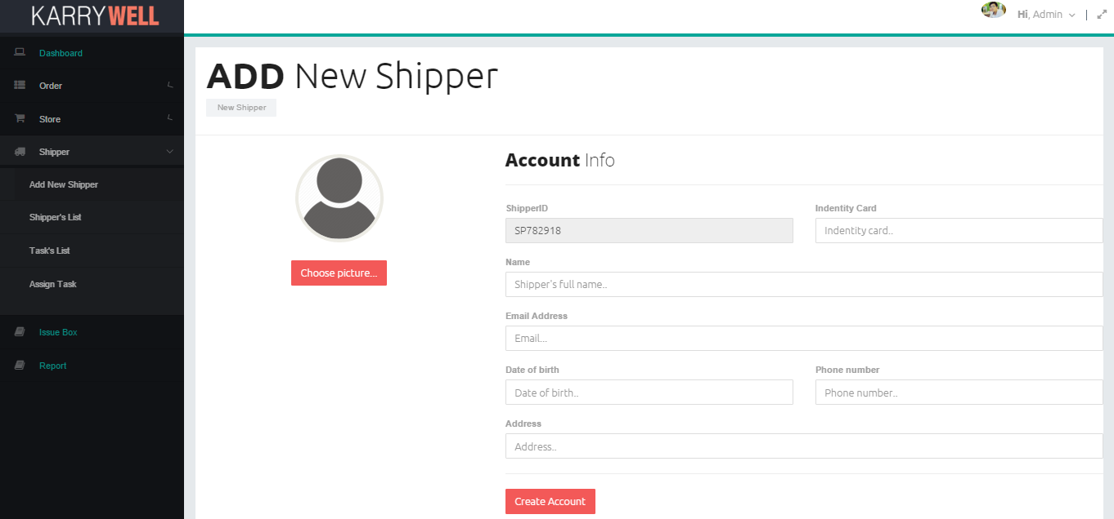

|  |  |  |  |  |  |
| --- | --- | --- | --- | --- | --- |
| **No** | **Elements** | **Sub-Element** | **Required** | **Type** | **Description** |
| 1. **1** | **Menu** |  | Click | List view | List of the pages ( Dashboard , Order(*Create Order ,Order’s List*) , Store(*Add Store, Store’s List, Transaction History*), Shipper*(Add Shipper, Shipper’s List, Task’s List, Assign Task*), Report , IssueBox ) which navigate directly to selected page |
| 1. **2** | **KARRYWELL logo** |  |  | Image | Logo of system |
| 1. **3** | **Header** | **Avatar** |  | Image | Avatar of user |
| **Notification** | Click | Button | Number of unread notification, click to view notification list |
| **Greeting** | Click | Drop-downlist | Include ‘Sign out’, ‘View Profile’ to log out or view user’s profile |
| **Full size** | Click | Button | Click to view page on full-screen |
| 1. **4** | **Add New Shipper title** |  |  | Label | Title |
| 1. **5** | **Avatar** |  |  | Image | Avatar of new shipper |
| 1. **6** | **Shipper ID** |  |  | Textbox | ShipperID of new Shipper |
| 1. **6** | **Identity card** |  |  | Textbox | Identity card of new Shipper |
| 1. **6** | **Name** |  |  | Textbox | Full name of new Shipper |
| 1. **6** | **Email** |  |  | Textbox | Email of new Shipper |
| 1. **6** | **Date of Birth** |  |  | DatePicker item | Date of birth of new Shipper |
| 1. **6** | **Phone number** |  |  | Textbox | Phone number of new Shipper |
| 1. **6** | **Address** |  |  | Textbox | Address of new Shipper |
| 1. **6** | **Create account** |  | Click | Button | Click to add new shipper to system |
|  | **Choose picture** |  | Click | Button | Click to add choose avatar for new Shipper |

#### 3.2.2.6. Shipper’s List Screen

Admin can view all shipper of system in map and in table

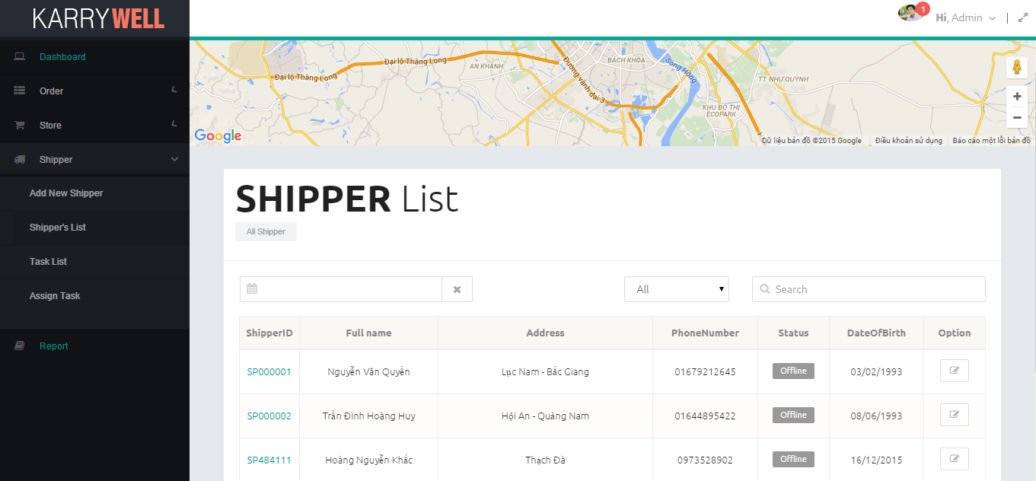

|  |  |  |  |  |  |
| --- | --- | --- | --- | --- | --- |
| **No** | **Elements** | **Sub-Element** | **Required** | **Type** | **Description** |
|  | **Menu** |  | Click | List view | List of the pages ( Dashboard , Order(*Create Order ,Order’s List*) , Store(*Add Store, Store’s List, Transaction History*), Shipper*(Add Shipper, Shipper’s List, Task’s List, Assign Task*), Report , IssueBox ) which navigate directly to selected page |
|  | **KARRYWELL logo** |  |  | Image | Logo of system |
|  | **Header** | **Avatar** |  | Image | Avatar of user |
| **Notification** | Click | Button | Number of unread notification, click to view notification list |
| **Greeting** | Click | Drop-downlist | Include ‘Sign out’, ‘View Profile’ to log out or view user’s profile |
| **Full size** | Click | Button | Click to view page on full-screen |
|  | **Shipper’s List title** |  |  | Label | Title |
|  | **Shipper table** | **Date range** | Click | Daterange-picker | Select date range for searching |
| **Clear** | Click | Button | Clear date range value |
| **Type filter** | Click | Drop-downlist | Select type for searching |
| **Search** |  | Textbox | Enter search key for searching |
| **Table** |  | Table item | Displays all shippers and related information (shipperid, full name, address, phone number, status, date of birth, update button). |
| **Page navigation** | Click | Navigation item | Click to select page number |

#### 3.2.2.7. Task’s List Screen

Admin can view all tasks of system in table

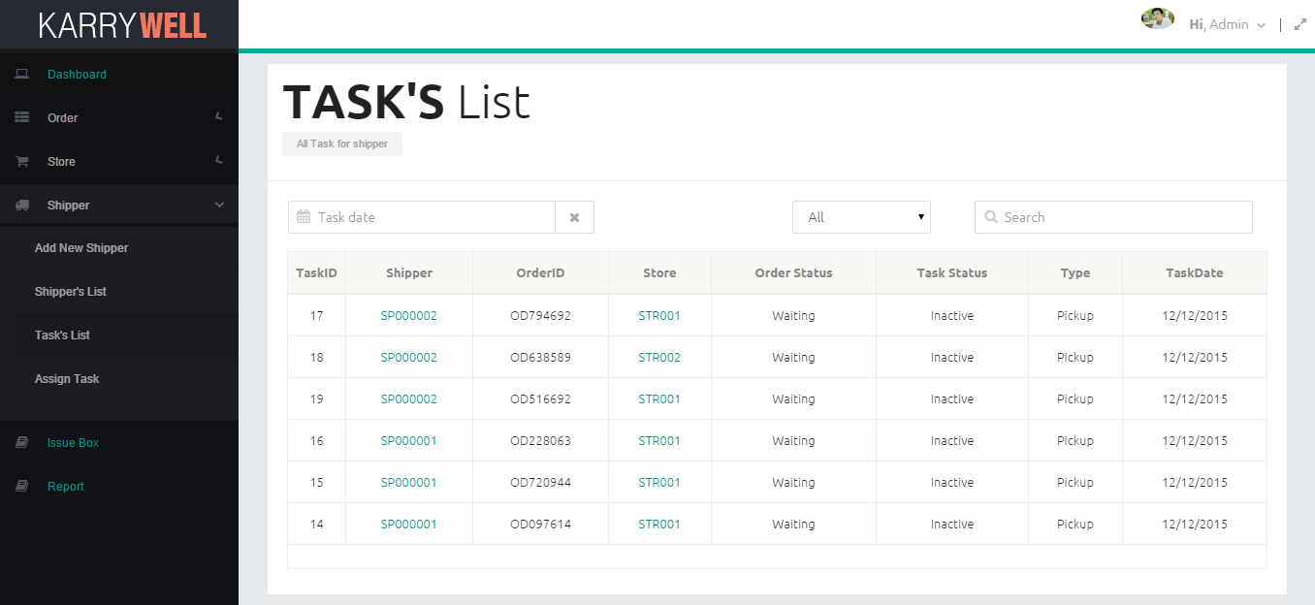

|  |  |  |  |  |  |
| --- | --- | --- | --- | --- | --- |
| **No** | **Elements** | **Sub-Element** | **Required** | **Type** | **Description** |
|  | **Menu** |  | Click | List view | List of the pages ( Dashboard , Order(*Create Order ,Order’s List*) , Store(*Add Store, Store’s List, Transaction History*), Shipper*(Add Shipper, Shipper’s List, Task’s List, Assign Task*), Report , IssueBox ) which navigate directly to selected page |
|  | **KARRYWELL logo** |  |  | Image | Logo of system |
|  | **Header** | **Avatar** |  | Image | Avatar of user |
| **Notification** | Click | Button | Number of unread notification, click to view notification list |
| **Greeting** | Click | Drop-downlist | Include ‘Sign out’, ‘View Profile’ to log out or view user’s profile |
| **Full size** | Click | Button | Click to view page on full-screen |
|  | **Task’s List title** |  |  | Label | Title |
|  | **Task table** | **Date range** | Click | Daterange-picker | Select date range for searching |
| **Clear** | Click | Button | Clear date range value |
| **Type filter** | Click | Drop-downlist | Select type for searching |
| **Search** |  | Textbox | Enter search key for searching |
| **Table** |  | Table item | Displays all tasks and related information (taskid, shipperid, orderid, storeid, order status, type, task date). |
| **Page navigation** | Click | Navigation item | Click to select page number |

#### 3.2.2.8. Assign Task Screen

Admin can assign orders for shippers

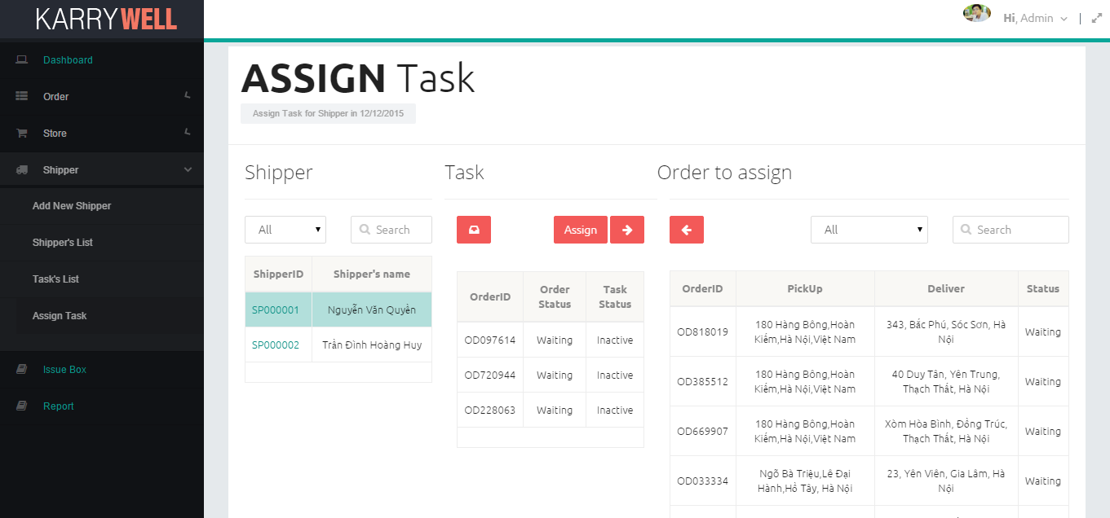

|  |  |  |  |  |  |
| --- | --- | --- | --- | --- | --- |
| **No** | **Elements** | **Sub-Element** | **Required** | **Type** | **Description** |
|  | **Menu** |  | Click | List view | List of the pages ( Dashboard , Order(*Create Order ,Order’s List*) , Store(*Add Store, Store’s List, Transaction History*), Shipper*(Add Shipper, Shipper’s List, Task’s List, Assign Task*), Report , IssueBox ) which navigate directly to selected page |
|  | **KARRYWELL logo** |  |  | Image | Logo of system |
|  | **Header** | **Avatar** |  | Image | Avatar of user |
| **Notification** | Click | Button | Number of unread notification, click to view notification list |
| **Greeting** | Click | Drop-downlist | Include ‘Sign out’, ‘View Profile’ to log out or view user’s profile |
| **Full size** | Click | Button | Click to view page on full-screen |
|  | **Assign Task title** |  |  | Label | Title |
|  | **Shipper table title** |  |  | Label | Title of shipper table |
|  | **Task table title** |  |  | Label | Title of Task of picked shipper table |
|  | **Order table title** |  |  | Label | Title of order table |
|  | **Assign** |  | Click | Button | Click to assign orders for shippers after picking orders and tasks |
|  | **Inbox** |  | Click | Button | Redirect to IssueBox page |
|  | **Move all to left** |  | Click | Button | Move all orders which was assigned for selected shipper to order table |
|  | **Move all to right** |  | Click | Button | Move all orders to task table to assign for selected shipper |
|  | **Shipper table** | **Type filter** | Click | Drop-downlist | Select type for searching |
|  | **Search** |  | Textbox | Enter search key for searching |
|  | **Table** |  | Table item | Displays all shippers can be assigned task and related information (shipperid, shipper’s name). |
|  | **Page navigation** | Click | Navigation item | Click to select page number |
|  | **Task table** |  |  | Table item | Displays all inactive tasks of selected shipper and related information (orderid, order status, task status). |
|  | **Order table** | **Type filter** | Click | Drop-downlist | Select type for searching |
| **Search** |  | Textbox | Enter search key for searching |
| **Table** |  | Table item | Displays all orders can be assigned for shipper and related information (orderid, pickup address, delivery address, status) |
| **Page navigation** | Click | Navigation item | Click to select page number |

#### 3.2.2.9. Order’s List Screen

Admin can view all orders of system in table

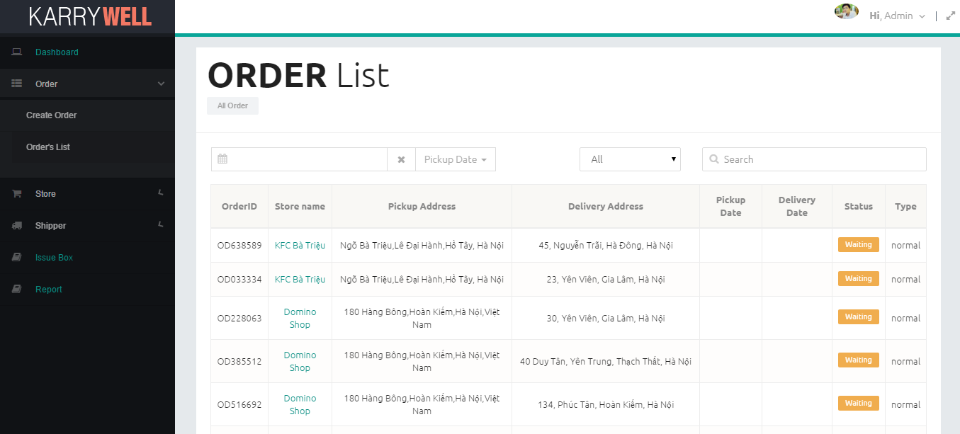

|  |  |  |  |  |  |
| --- | --- | --- | --- | --- | --- |
| **No** | **Elements** | **Sub-Element** | **Required** | **Type** | **Description** |
|  | **Menu** |  | Click | List view | List of the pages ( Dashboard , Order(*Create Order ,Order’s List*) , Store(*Add Store, Store’s List, Transaction History*), Shipper*(Add Shipper, Shipper’s List, Task’s List, Assign Task*), Report , IssueBox ) which navigate directly to selected page |
|  | **KARRYWELL logo** |  |  | Image | Logo of system |
|  | **Header** | **Avatar** |  | Image | Avatar of user |
| **Notification** | Click | Button | Number of unread notification, click to view notification list |
| **Greeting** | Click | Drop-downlist | Include ‘Sign out’, ‘View Profile’ to log out or view user’s profile |
| **Full size** | Click | Button | Click to view page on full-screen |
|  | **Order’s List title** |  |  | Label | Title |
|  | **Order table** | **Date range** | Click | Daterange-picker | Select date range for searching |
| **Clear** | Click | Button | Clear date range value |
| **Type filter** | Click | Drop-downlist | Select type for searching |
| **Search** |  | Textbox | Enter search key for searching |
| **Table** |  | Table item | Displays all orders and related information (orderid, store’s name, pickup address, delivery address, pickup date, delivery date, status, type). |
| **Page navigation** | Click | Navigation item | Click to select page number |

#### 3.2.2.10. IssueBox Screen

Admin can view all orders of system in table

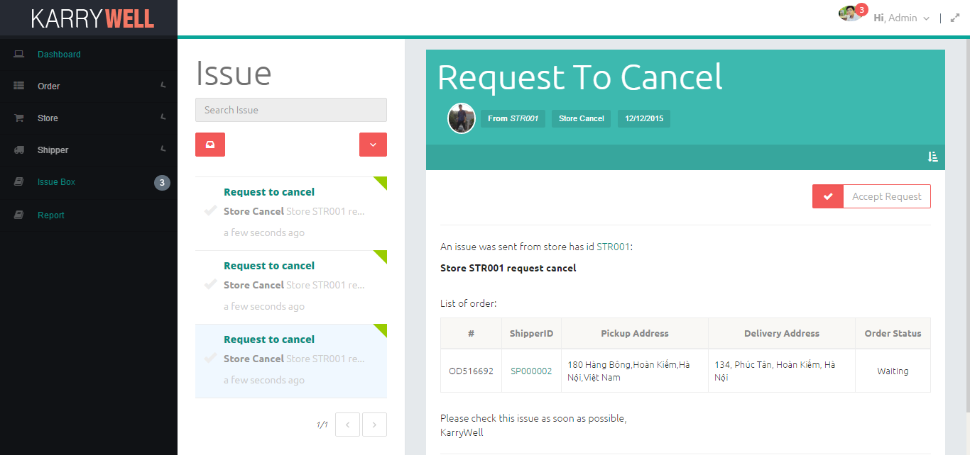

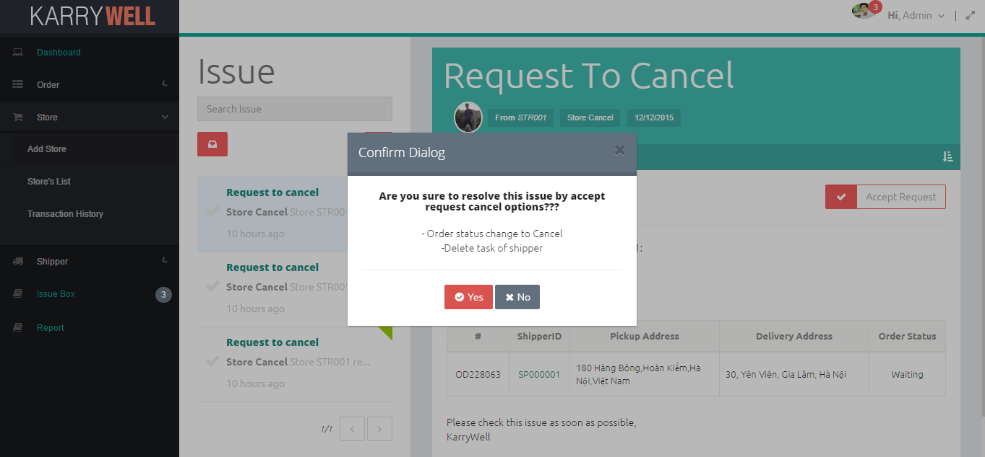

|  |  |  |  |  |  |  |
| --- | --- | --- | --- | --- | --- | --- |
| **No** | **Elements** | **Sub-Element** | **Required** | **Type** | **Default** | **Description** |
|  | **Menu** |  | Click | List view |  | List of the pages ( Dashboard , Order(*Create Order ,Order’s List*) , Store(*Add Store, Store’s List, Transaction History*), Shipper*(Add Shipper, Shipper’s List, Task’s List, Assign Task*), Report , IssueBox ) which navigate directly to selected page |
|  | **KARRYWELL logo** |  |  | Image |  | Logo of system |
|  | **Header** | **Avatar** |  | Image |  | Avatar of user |
| **Notification** | Click | Button |  | Number of unread notification, click to view notification list |
| **Greeting** | Click | Drop-downlist |  | Include ‘Sign out’, ‘View Profile’ to log out or view user’s profile |
| **Full size** | Click | Button |  | Click to view page on full-screen |
|  | **Issue title** |  |  | Label |  | Title |
|  | **Issue List** | **Filter** | Click | Drop-downlist |  | Filter issue with picked type: Resolved, Unresolved, Shipper Pending, Shipper Cancel, Store Cancel |
| **All Issue** | Click | Button |  | List all issue |
| **Search** |  | Textbox |  | Enter search key for searching |
| **Issue List** |  | List View |  | Displays all issue and related information (type, category, content, time) |
| **Page navigation** | Click | Navigation item |  | Click to select page number |
|  | **Issue Content** | **Category** |  | Label |  | Category of issue |
| **Sender avatar** |  | Image |  | Avatar of sender |
| **Sender** |  | Label |  | Name of sender |
| **Time** |  | Label |  | When issue is sent |
| **Resolve** | Click | Button |  | There are 3 types: Continue, Change Shipper and Accept Request |
| **Content** |  | Label |  | Content of issue |
| **Orders** |  | Table item |  | Displays all orders which get issue and related information (orderid, store’s name, pickup address, delivery address, status). |
|  | **Confirm Resolve** | **Popup title** |  | Label | Hide | “Confirm Dialog” title |
| **Close** | Click | Button | Hide | Click to close popup |
| **Confirm** |  | Label | Hide | Confirmation text |
| **Description** |  | Label | Hide | What system will do to resolve issue |
| **Yes** | Click | Button | Hide | Click to confirm yes |
| **Cancel** | Click | Button | Hide | Click to cancel |

#### 3.2.2.11. User Detail Screen

Admin can view detail information of user

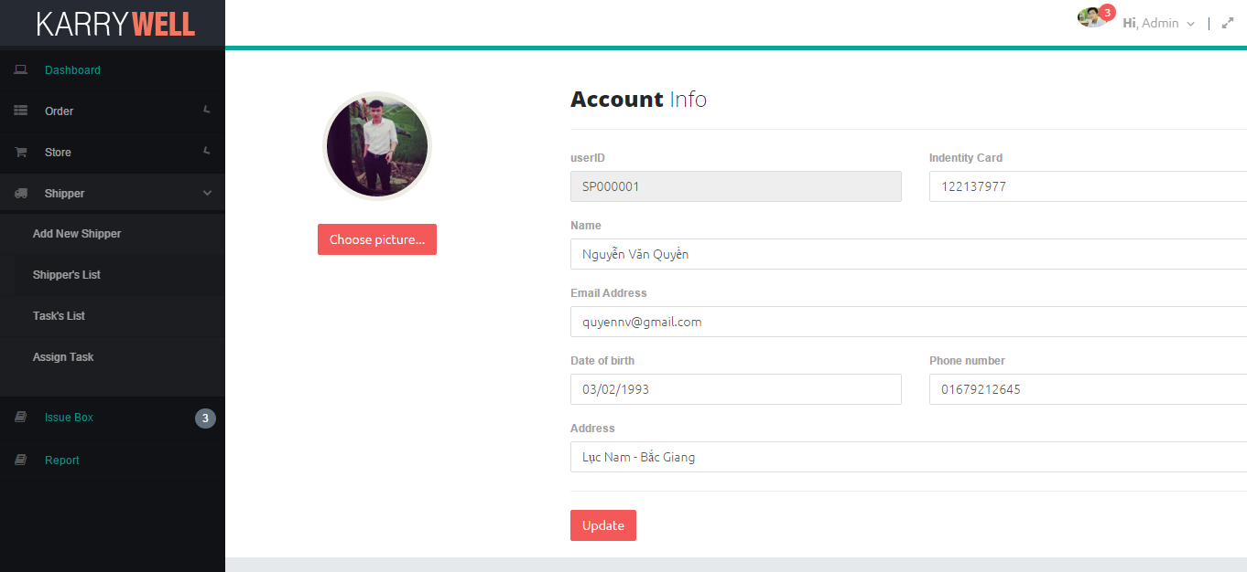

|  |  |  |  |  |  |
| --- | --- | --- | --- | --- | --- |
| **No** | **Elements** | **Sub-Element** | **Required** | **Type** | **Description** |
|  | **Menu** |  | Click | List view | List of the pages ( Dashboard , Order(*Create Order ,Order’s List*) , Store(*Add Store, Store’s List, Transaction History*), Shipper*(Add Shipper, Shipper’s List, Task’s List, Assign Task*), Report , IssueBox ) which navigate directly to selected page |
|  | **KARRYWELL logo** |  |  | Image | Logo of system |
|  | **Header** | **Avatar** |  | Image | Avatar of user |
| **Notification** | Click | Button | Number of unread notification, click to view notification list |
| **Greeting** | Click | Drop-downlist | Include ‘Sign out’, ‘View Profile’ to log out or view user’s profile |
| **Full size** | Click | Button | Click to view page on full-screen |
|  | **Account Info title** |  |  | Label | Title |
|  | **Avatar** |  |  | Image | Avatar of user |
|  | **Choose picture** |  | Click | Button | Click to change avatar |
|  | **Username** |  |  | Label | Username of user |
|  | **Identity card** |  |  | Textbox | Identity card of user |
|  | **Name** |  |  | Textbox | Full name of user |
|  | **Email** |  |  | Textbox | Email of user |
|  | **Date of Birth** |  |  | DatePicker item | Date of birth of user |
|  | **Phone number** |  |  | Textbox | Phone number of user |
|  | **Address** |  |  | Textbox | Address of user |
|  | **Update** |  | Click | Button | Click to update new information that modified for user |

#### 3.2.2.11. Store Detail Screen

Admin can view detail information of store

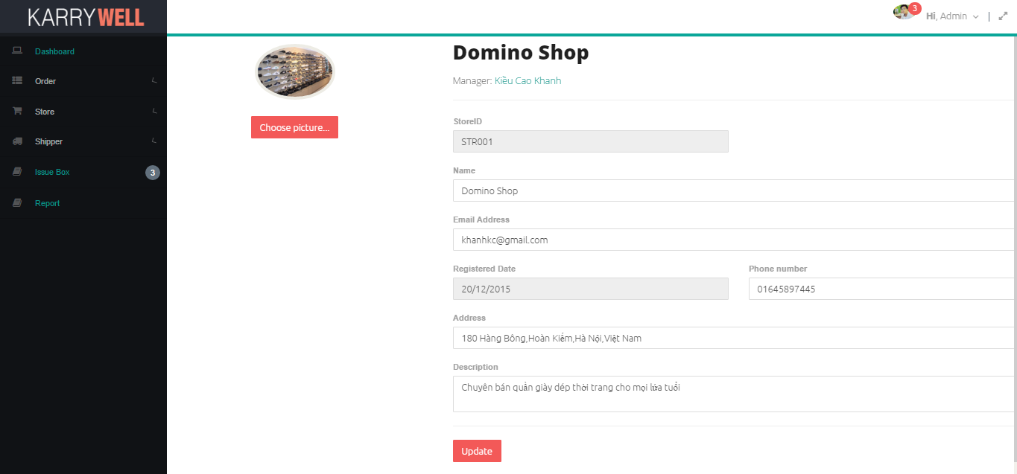

|  |  |  |  |  |  |
| --- | --- | --- | --- | --- | --- |
| **No** | **Elements** | **Sub-Element** | **Required** | **Type** | **Description** |
|  | **Menu** |  | Click | List view | List of the pages ( Dashboard , Order(*Create Order ,Order’s List*) , Store(*Add Store, Store’s List, Transaction History*), Shipper*(Add Shipper, Shipper’s List, Task’s List, Assign Task*), Report , IssueBox ) which navigate directly to selected page |
|  | **KARRYWELL logo** |  |  | Image | Logo of system |
|  | **Header** | **Avatar** |  | Image | Avatar of user |
| **Notification** | Click | Button | Number of unread notification, click to view notification list |
| **Greeting** | Click | Drop-downlist | Include ‘Sign out’, ‘View Profile’ to log out or view user’s profile |
| **Full size** | Click | Button | Click to view page on full-screen |
|  | **Store’s name title** |  |  | Label | Title |
|  | **Avatar** |  |  | Image | Avatar of store |
|  | **Choose picture** |  | Click | Button | Click to change avatar |
|  | **Store Manager** |  | Click | Hyperlink | Link to store’s owner detail |
|  | **StoreID** |  |  | Label | StoreID of store |
|  | **Name** |  |  | Textbox | Name of store |
|  | **Email** |  |  | Textbox | Email of store |
|  | **Registered Date** |  |  | Textbox | Registered date of store |
|  | **Phone number** |  |  | Textbox | Phone number of store |
|  | **Address** |  |  | Textbox | Address of store |
|  | **Description** |  |  | Textbox | Description about store |
|  | **Update** |  | Click | Button | Click to update new information that modified for store |